Google console application for OAuth2 authentication:

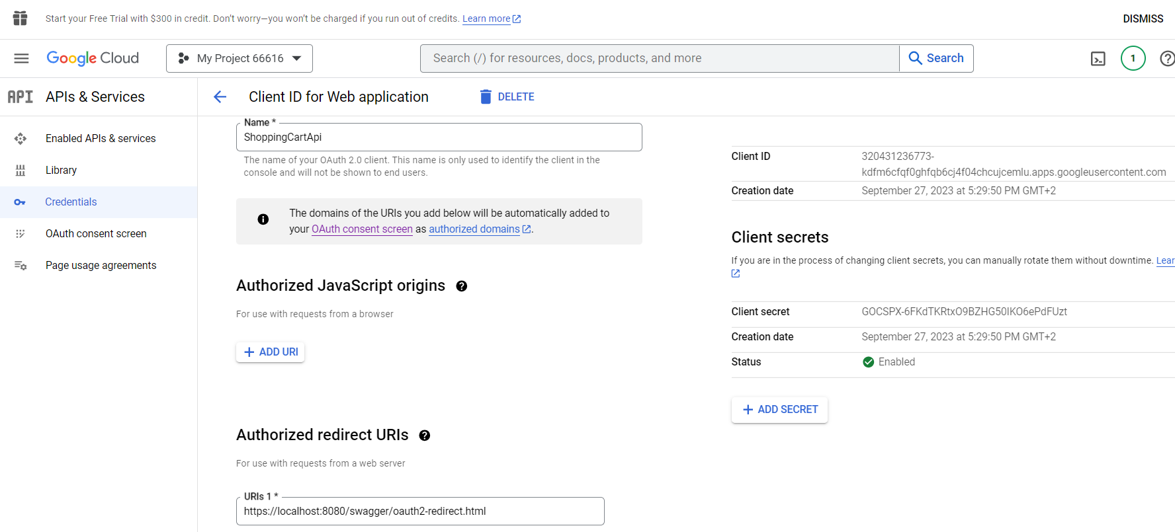

The link provided below where you can view a demo of how the google OAuth2 would work provided the shoppingCartRest api is running on https://localhost:8080/swagger/index.html:

<https://screenrec.com/share/OxXdJ6iIuy>